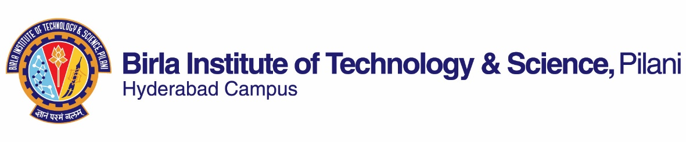

**SECOND SEMESTER 2020-2021**

# Course Handout Part II

Date: 16-01-2021

In addition to part-I (General Handout for all courses appended to the time table) this portion gives further specific details regarding the course.

*Course No.* : CHEM F335

## Course Title : Organic Chemistry and Drug Design

## Instructor-in-Charge : **K V G Chandra Sekhar**

*Instructor* : Khetmalis Yogesh Mahadu

**Scope and Objective of the Course:** To familiarize the students with basic aspects of drug discovery and more importantly, the applications of organic chemistry in drug design, important drug targets, marketed drugs, synthesis of drugs; the overall objective is to have a reflective teaching and learning environment

**Textbooks:**

1. An Introduction to Medicinal Chemistry by Graham L. Patrick, Oxford University Press, 5th edition.

**Reference books**

1. Medicinal Chemistry by Ashutosh Kar, New Age International Publishers, 7th edition
2. The Organic Chemistry of Drug Design and Drug Action by Richard B Silverman, Academic press, 2nd edition.
3. Principles of Medicinal Chemistry by William O Foye, Lea and Febiger, Phil., 6th edition.

**Learning Outcomes**: The learner should be able to accomplish the following:

1. Able to identify and list at least five biological targets for drugs
2. From the above targets, be able to analyze and choose suitable targets for a disease with rationale
3. For the above targets be able to identify ten important available drugs, with the corresponding Structure-Activity Relationship (SAR)
4. At the end, be able to rationally design and propose simple synthesis of a drug for a given disease.

**Course Plan:**

|  |  |  |  |
| --- | --- | --- | --- |
| **Lec. No.** | **Learning objectives** | **Topics to be Covered** | **Chapter in the Text Book** |
| 1-13 | Drugs and Drug targets | Introduction, drug targets, intermolecular bonding forces, classification of drugs, naming of drugs and medicines, structures and functions of protein, enzymes, receptors, and nucleic acids, receptors and signal transduction; miscellaneous drug targets | T: 1-10; Lecture notes |
| 14-17 | Pharmacokinetics | Molecular interaction with receptors and enzymes; absorption, distribution, metabolism, and elimination of drugs, concept of prodrugs | T:11 |
| 18-23 | Drug discovery, design, and development | Finding a lead; choosing a disease, target, and bioassay; finding leads from natural drugs, synthetic compounds libraries, existing drugs; optimizing target interactions; SAR; drug development: preclinical and clinical trials; patenting and regulatory affairs | T: 12-15 |
| 24-28 | Antimicrobial agents | Introduction, classification, synthesis, and design of Sulfonamides; penicillins; cephalosporins; β-lactam antibiotics; quinolones and fluroquinolones; aminoglycosides | T:19, lecture notes |
| 29-33 | Antiviral agents | Broad spectrum antiviral agents: introduction; synthesis, and design against DNA viruses; RNA viruses/HIV; protease inhibitors, | T:20 |
| 34-38 | Anticancer agents | Cancer; drugs acting on nucleic acids; antimetabolites; hormone-based therapies; inhibitors of signaling pathways | T: 21 |

**Evaluation Scheme:**

|  |  |  |  |  |
| --- | --- | --- | --- | --- |
| **Component** | **Duration** | **Weightage (%)** | **Date & Time** | **Nature of Component** |
| Mid-semester Test | 90 min | 30 | 06/03; 900 -1030 AM | Open book |
| Class tests* | 15 min. each | 20 | Continuous | Open book |
| Presentation | 10 min. | 10 | In April first week | Open book |
| Comprehensive Examination | 120 min. | 40 | 17/05 FN | Open book |

* 5 class tests will be conducted and best 4 will be considered. Make up is not permissible for class tests.

**Note:** *Active and regular participation in the online class discussions is expected from each student.*

**Chamber Consultation Hour:** Monday, 10 – 11 AM

**Notices:** All the notices pertaining to this course will be displayed on **CMS only**.

**Make-up Policy:** Will be granted only for genuine reasons decided by the instructor.

**Academic Honesty and Integrity Policy:** Academic honesty and integrity are to be maintained by all the students throughout the semester and no type of academic dishonesty is acceptable.

**Final grading** will be done on the basis of the overall performance of a student in each of the components as listed under evaluation scheme. For **mid-semester grading**, progress made by a student up to that point of time would be evaluated.

**INSTRUCTOR-IN-CHARGE**

**KVG Chandra Sekhar**